Chapter-7

1.

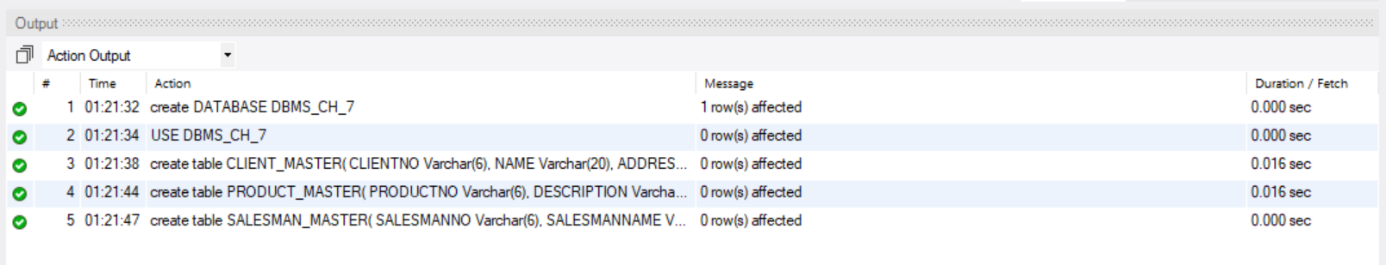

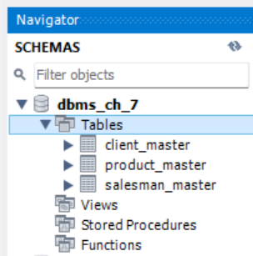

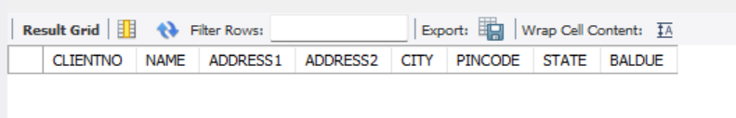

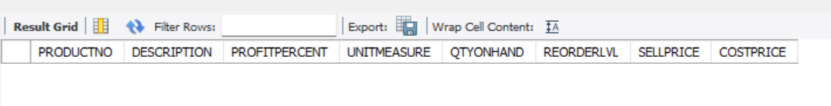

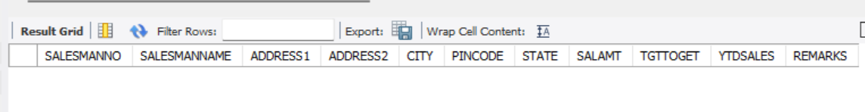

-- Create Table CLIENT_MASTER 1 NO

create table CLIENT_MASTER(

CLIENTNO Varchar(6),

NAME Varchar(20),

ADDRESS1 Varchar(30),

ADDRESS2 Varchar(30),

CITY Varchar(15),

PINCODE numeric(8),

STATE Varchar(15),

BALDUE Numeric(10,2)

);

-- Create Table PRODUCT_MASTER 1 no

create table PRODUCT_MASTER(

PRODUCTNO Varchar(6),

DESCRIPTION Varchar(15),

PROFITPERCENT Numeric(4,2),

UNITMEASURE Varchar(10),

QTYONHAND Numeric(8),

REORDERLVL Numeric(8),

SELLPRICE Numeric(8,2),

COSTPRICE Numeric(8,2)

);

-- Create Table SALESMAN_MASTER 1 no

create table SALESMAN_MASTER(

SALESMANNO Varchar(6),

SALESMANNAME Varchar(20),

ADDRESS1 Varchar(30),

ADDRESS2 Varchar(30),

CITY Varchar(20),

PINCODE Numeric(8),

STATE Varchar(20),

SALAMT Numeric(8,2),

TGTTOGET Numeric(6,2),

YTDSALES Numeric(6,2),

REMARKS Varchar(60)

);

2. a) CLIENT_MASTER TABLE:

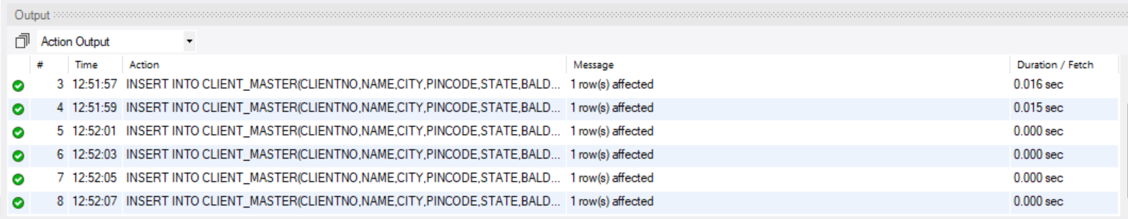

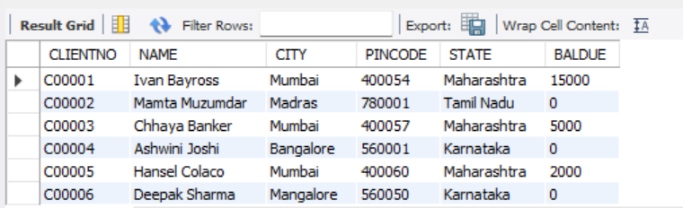

-- Create Table CLIENT_MASTER 2 N0 VALUE INSERT JONNO

create table CLIENT_MASTER(

CLIENTNO Varchar(6),

NAME Varchar(20),

CITY Varchar(15),

PINCODE integer(8),

STATE Varchar(15),

BALDUE integer(10)

);

-- Insert Value in CLIENT_MASTER Table

INSERT INTO CLIENT_MASTER(CLIENTNO,NAME,CITY,PINCODE,STATE,BALDUE) VALUES('C00001','Ivan Bayross','Mumbai',400054,'Maharashtra',15000);

INSERT INTO CLIENT_MASTER(CLIENTNO,NAME,CITY,PINCODE,STATE,BALDUE) VALUES('C00002','Mamta Muzumdar','Madras',780001,'Tamil Nadu',0);

INSERT INTO CLIENT_MASTER(CLIENTNO,NAME,CITY,PINCODE,STATE,BALDUE) VALUES('C00003','Chhaya Banker','Mumbai',400057,'Maharashtra',5000);

INSERT INTO CLIENT_MASTER(CLIENTNO,NAME,CITY,PINCODE,STATE,BALDUE) VALUES('C00004','Ashwini Joshi','Bangalore',560001,'Karnataka',0);

INSERT INTO CLIENT_MASTER(CLIENTNO,NAME,CITY,PINCODE,STATE,BALDUE) VALUES('C00005','Hansel Colaco','Mumbai',400060,'Maharashtra',2000);

INSERT INTO CLIENT_MASTER(CLIENTNO,NAME,CITY,PINCODE,STATE,BALDUE) VALUES('C00006','Deepak Sharma','Mangalore',560050,'Karnataka',0);

2.b)

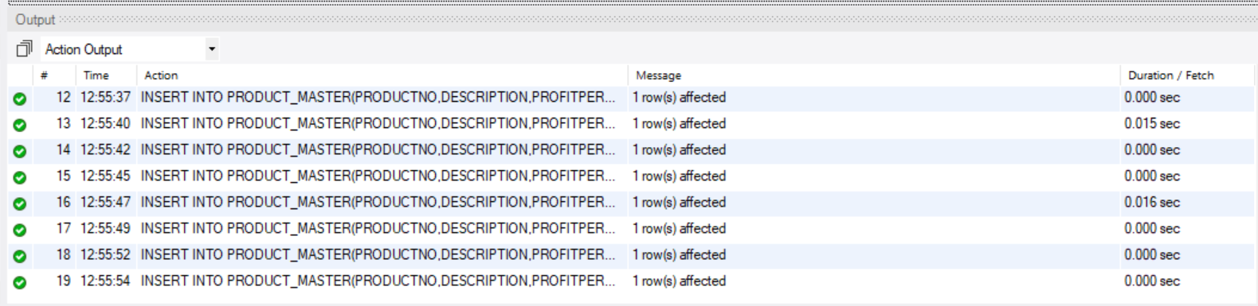

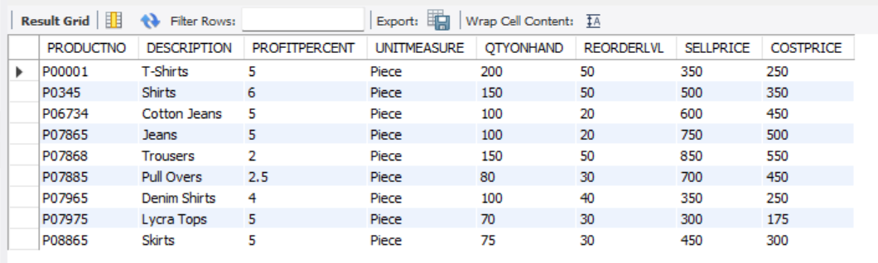

-- Create Table PRODUCT_MASTER 2 no value insert jonno

create table PRODUCT_MASTER(

PRODUCTNO Varchar(6),

DESCRIPTION Varchar(15),

PROFITPERCENT float(4),

UNITMEASURE Varchar(10),

QTYONHAND integer(8),

REORDERLVL integer(8),

SELLPRICE integer(8),

COSTPRICE integer(8)

);

-- Insert Value in PRODUCT_MASTER Table

INSERT INTO PRODUCT_MASTER(PRODUCTNO,DESCRIPTION,PROFITPERCENT,UNITMEASURE,QTYONHAND,REORDERLVL,SELLPRICE,COSTPRICE) VALUES('P00001','T-Shirts',5,'Piece',200,50,350,250);

INSERT INTO PRODUCT_MASTER(PRODUCTNO,DESCRIPTION,PROFITPERCENT,UNITMEASURE,QTYONHAND,REORDERLVL,SELLPRICE,COSTPRICE) VALUES('P0345','Shirts',6,'Piece',150,50,500,350);

INSERT INTO PRODUCT_MASTER(PRODUCTNO,DESCRIPTION,PROFITPERCENT,UNITMEASURE,QTYONHAND,REORDERLVL,SELLPRICE,COSTPRICE) VALUES('P06734','Cotton Jeans',5,'Piece',100,20,600,450);

INSERT INTO PRODUCT_MASTER(PRODUCTNO,DESCRIPTION,PROFITPERCENT,UNITMEASURE,QTYONHAND,REORDERLVL,SELLPRICE,COSTPRICE) VALUES('P07865','Jeans',5,'Piece',100,20,750,500);

INSERT INTO PRODUCT_MASTER(PRODUCTNO,DESCRIPTION,PROFITPERCENT,UNITMEASURE,QTYONHAND,REORDERLVL,SELLPRICE,COSTPRICE) VALUES('P07868','Trousers',2,'Piece',150,50,850,550);

INSERT INTO PRODUCT_MASTER(PRODUCTNO,DESCRIPTION,PROFITPERCENT,UNITMEASURE,QTYONHAND,REORDERLVL,SELLPRICE,COSTPRICE) VALUES('P07885','Pull Overs',2.5,'Piece',80,30,700,450);

INSERT INTO PRODUCT_MASTER(PRODUCTNO,DESCRIPTION,PROFITPERCENT,UNITMEASURE,QTYONHAND,REORDERLVL,SELLPRICE,COSTPRICE) VALUES('P07965','Denim Shirts',4,'Piece',100,40,350,250);

INSERT INTO PRODUCT_MASTER(PRODUCTNO,DESCRIPTION,PROFITPERCENT,UNITMEASURE,QTYONHAND,REORDERLVL,SELLPRICE,COSTPRICE) VALUES('P07975','Lycra Tops',5,'Piece',70,30,300,175);

INSERT INTO PRODUCT_MASTER(PRODUCTNO,DESCRIPTION,PROFITPERCENT,UNITMEASURE,QTYONHAND,REORDERLVL,SELLPRICE,COSTPRICE) VALUES('P08865','Skirts',5,'Piece',75,30,450,300);

2.c)

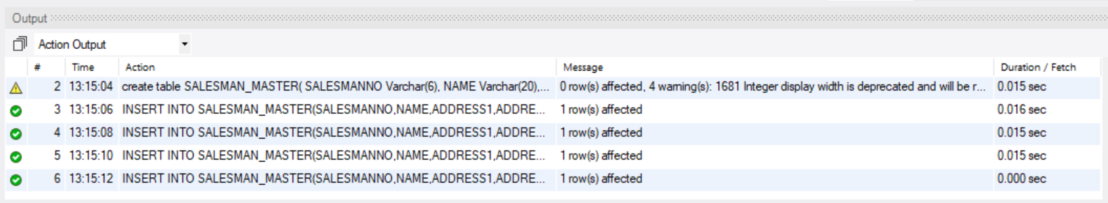

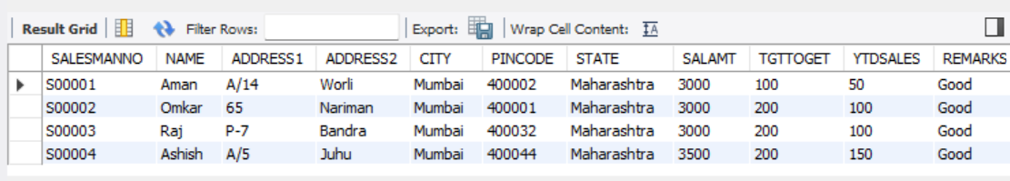

-- Create Table SALESMAN_MASTER 1 no

create table SALESMAN_MASTER(

SALESMANNO Varchar(6),

NAME Varchar(20),

ADDRESS1 Varchar(30),

ADDRESS2 Varchar(30),

CITY Varchar(20),

PINCODE integer(8),

STATE Varchar(20),

SALAMT integer(8),

TGTTOGET integer(6),

YTDSALES integer(6),

REMARKS Varchar(60)

);

-- Insert Value in SALESMAN_MASTER Table

INSERT INTO SALESMAN_MASTER(SALESMANNO,NAME,ADDRESS1,ADDRESS2,CITY,PINCODE,STATE,SALAMT,TGTTOGET,YTDSALES,REMARKS) VALUES('S00001','Aman','A/14','Worli','Mumbai',400002,'Maharashtra',3000,100,50,'Good');

INSERT INTO SALESMAN_MASTER(SALESMANNO,NAME,ADDRESS1,ADDRESS2,CITY,PINCODE,STATE,SALAMT,TGTTOGET,YTDSALES,REMARKS) VALUES('S00002','Omkar','65','Nariman','Mumbai',400001,'Maharashtra',3000,200,100,'Good');

INSERT INTO SALESMAN_MASTER(SALESMANNO,NAME,ADDRESS1,ADDRESS2,CITY,PINCODE,STATE,SALAMT,TGTTOGET,YTDSALES,REMARKS) VALUES('S00003','Raj','P-7','Bandra','Mumbai',400032,'Maharashtra',3000,200,100,'Good');

INSERT INTO SALESMAN_MASTER(SALESMANNO,NAME,ADDRESS1,ADDRESS2,CITY,PINCODE,STATE,SALAMT,TGTTOGET,YTDSALES,REMARKS) VALUES('S00004','Ashish','A/5','Juhu','Mumbai',400044,'Maharashtra',3500,200,150,'Good');

3.a)

select Name from client_master;

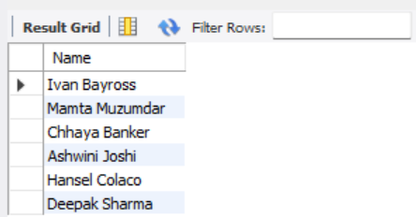

3.b) select * from client_master;

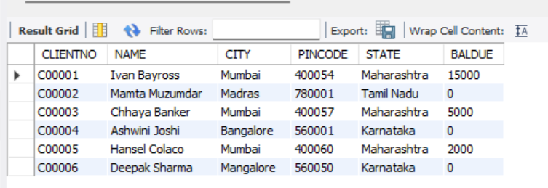

3.c) select Name,City,State from client_master;

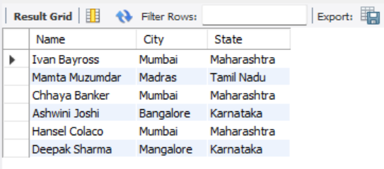

3.d) select Description from product_master;

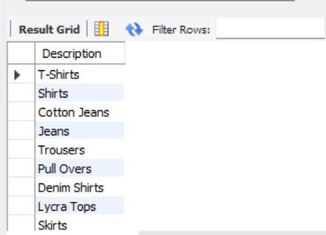

3.e) select * from client_master where City='Mumbai';

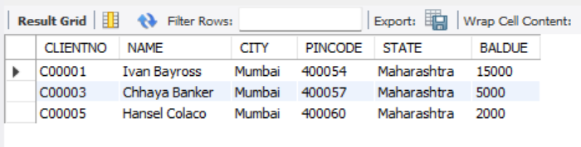

3.F) select Name from SALESMAN_master where SALAMT=3000;

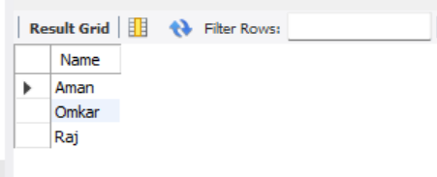

4.a)Before:



update client_master set City='Bangalore' where CLIENTNO='C00005';



Update:

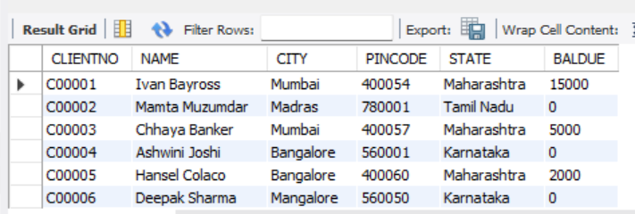

4.b) Before:



update client_master set BALDUE=1000 where CLIENTNO='C00001';



Update:

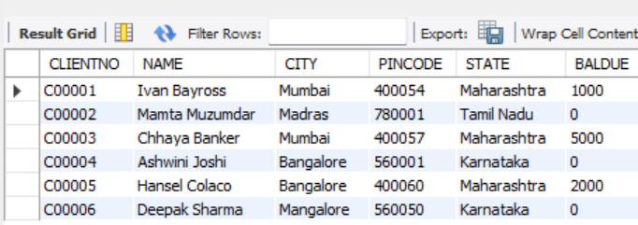

4.c) Before:



update product_master set COSTPRICE=950.00 where DESCRIPTION='Trousers';



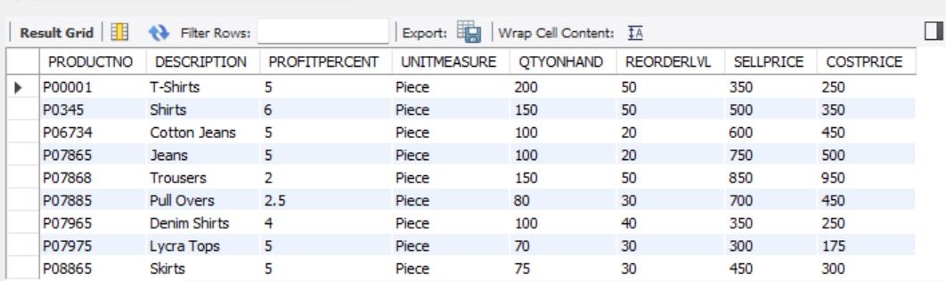

4.d) Before:



update salesman_master set City='Pune';



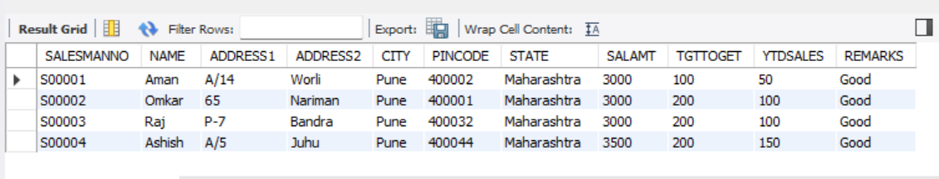

5.a) Before:



delete from salesman_master where SALAMT=3500;



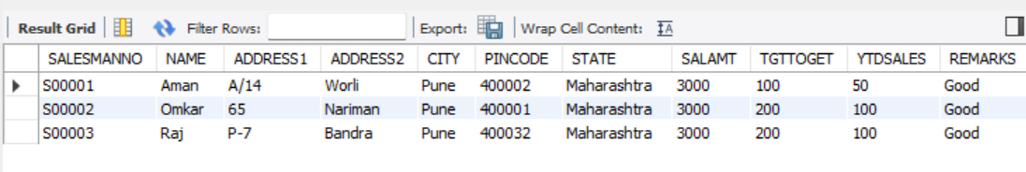

5.B)Before:



delete from product_master where QTYONHAND=100;



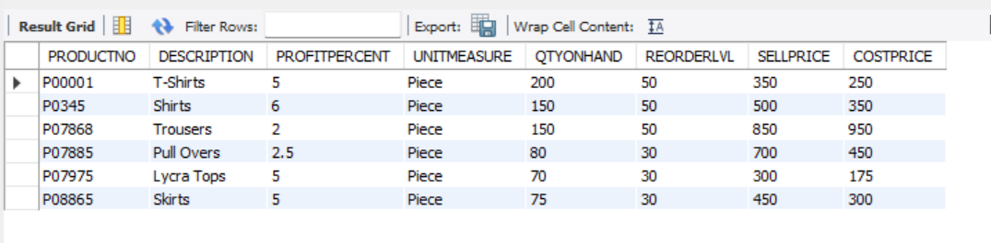

5.c)Before:



delete from client_master where STATE='Tamil Nadu';



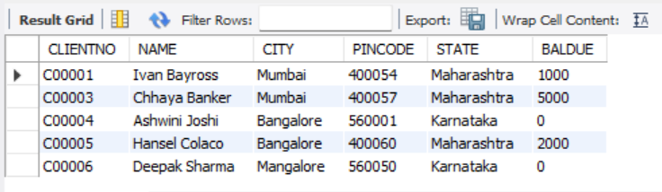

6.a)Before:



alter table client_master add Telephone integer (10);



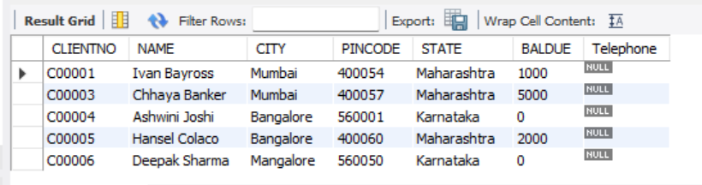

6.b)Before:



alter table product_master modify SELLPRICE integer(10);



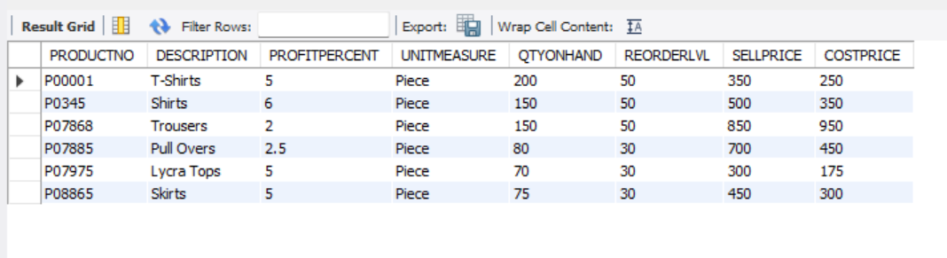

7.a)Before:





drop table client_master;



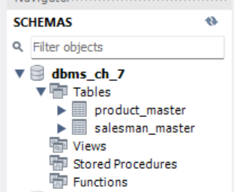

8.a)Before:



alter table salesman_master rename to sman_mast;



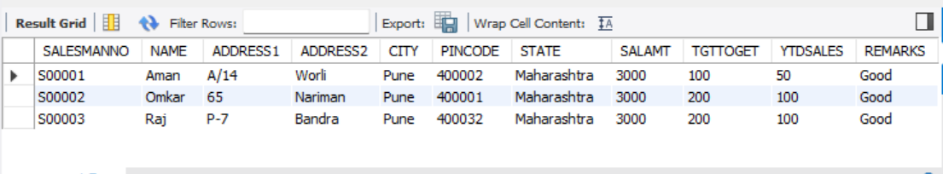

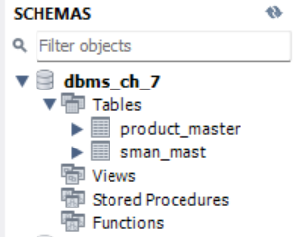

-- Create Database

create DATABASE DBMS_CH_7;

USE DBMS_CH_7;

-- Create Table CLIENT_MASTER 1 NO

create table CLIENT_MASTER(

CLIENTNO Varchar(6),

NAME Varchar(20),

ADDRESS1 Varchar(30),

ADDRESS2 Varchar(30),

CITY Varchar(15),

PINCODE numeric(8),

STATE Varchar(15),

BALDUE Numeric(10,2)

);

-- Create Table PRODUCT_MASTER 1 no

create table PRODUCT_MASTER(

PRODUCTNO Varchar(6),

DESCRIPTION Varchar(15),

PROFITPERCENT Numeric(4,2),

UNITMEASURE Varchar(10),

QTYONHAND Numeric(8),

REORDERLVL Numeric(8),

SELLPRICE Numeric(8,2),

COSTPRICE Numeric(8,2)

);

-- Create Table SALESMAN_MASTER 1 no

create table SALESMAN_MASTER(

SALESMANNO Varchar(6),

SALESMANNAME Varchar(20),

ADDRESS1 Varchar(30),

ADDRESS2 Varchar(30),

CITY Varchar(20),

PINCODE Numeric(8),

STATE Varchar(20),

SALAMT Numeric(8,2),

TGTTOGET Numeric(6,2),

YTDSALES Numeric(6,2),

REMARKS Varchar(60)

);

-- Create Table CLIENT_MASTER 2 N0 VALUE INSERT JONNO

create table CLIENT_MASTER(

CLIENTNO Varchar(6),

NAME Varchar(20),

CITY Varchar(15),

PINCODE integer(8),

STATE Varchar(15),

BALDUE integer(10)

);

-- Insert Value in CLIENT_MASTER Table

INSERT INTO CLIENT_MASTER(CLIENTNO,NAME,CITY,PINCODE,STATE,BALDUE) VALUES('C00001','Ivan Bayross','Mumbai',400054,'Maharashtra',15000);

INSERT INTO CLIENT_MASTER(CLIENTNO,NAME,CITY,PINCODE,STATE,BALDUE) VALUES('C00002','Mamta Muzumdar','Madras',780001,'Tamil Nadu',0);

INSERT INTO CLIENT_MASTER(CLIENTNO,NAME,CITY,PINCODE,STATE,BALDUE) VALUES('C00003','Chhaya Banker','Mumbai',400057,'Maharashtra',5000);

INSERT INTO CLIENT_MASTER(CLIENTNO,NAME,CITY,PINCODE,STATE,BALDUE) VALUES('C00004','Ashwini Joshi','Bangalore',560001,'Karnataka',0);

INSERT INTO CLIENT_MASTER(CLIENTNO,NAME,CITY,PINCODE,STATE,BALDUE) VALUES('C00005','Hansel Colaco','Mumbai',400060,'Maharashtra',2000);

INSERT INTO CLIENT_MASTER(CLIENTNO,NAME,CITY,PINCODE,STATE,BALDUE) VALUES('C00006','Deepak Sharma','Mangalore',560050,'Karnataka',0);

-- Show Data From Table

select * From CLIENT_MASTER;

-- Create Table PRODUCT_MASTER 2 no value insert jonno

create table PRODUCT_MASTER(

PRODUCTNO Varchar(6),

DESCRIPTION Varchar(15),

PROFITPERCENT float(4),

UNITMEASURE Varchar(10),

QTYONHAND integer(8),

REORDERLVL integer(8),

SELLPRICE integer(8),

COSTPRICE float(8)

);

-- Insert Value in PRODUCT_MASTER Table

INSERT INTO PRODUCT_MASTER(PRODUCTNO,DESCRIPTION,PROFITPERCENT,UNITMEASURE,QTYONHAND,REORDERLVL,SELLPRICE,COSTPRICE) VALUES('P00001','T-Shirts',5,'Piece',200,50,350,250);

INSERT INTO PRODUCT_MASTER(PRODUCTNO,DESCRIPTION,PROFITPERCENT,UNITMEASURE,QTYONHAND,REORDERLVL,SELLPRICE,COSTPRICE) VALUES('P0345','Shirts',6,'Piece',150,50,500,350);

INSERT INTO PRODUCT_MASTER(PRODUCTNO,DESCRIPTION,PROFITPERCENT,UNITMEASURE,QTYONHAND,REORDERLVL,SELLPRICE,COSTPRICE) VALUES('P06734','Cotton Jeans',5,'Piece',100,20,600,450);

INSERT INTO PRODUCT_MASTER(PRODUCTNO,DESCRIPTION,PROFITPERCENT,UNITMEASURE,QTYONHAND,REORDERLVL,SELLPRICE,COSTPRICE) VALUES('P07865','Jeans',5,'Piece',100,20,750,500);

INSERT INTO PRODUCT_MASTER(PRODUCTNO,DESCRIPTION,PROFITPERCENT,UNITMEASURE,QTYONHAND,REORDERLVL,SELLPRICE,COSTPRICE) VALUES('P07868','Trousers',2,'Piece',150,50,850,550);

INSERT INTO PRODUCT_MASTER(PRODUCTNO,DESCRIPTION,PROFITPERCENT,UNITMEASURE,QTYONHAND,REORDERLVL,SELLPRICE,COSTPRICE) VALUES('P07885','Pull Overs',2.5,'Piece',80,30,700,450);

INSERT INTO PRODUCT_MASTER(PRODUCTNO,DESCRIPTION,PROFITPERCENT,UNITMEASURE,QTYONHAND,REORDERLVL,SELLPRICE,COSTPRICE) VALUES('P07965','Denim Shirts',4,'Piece',100,40,350,250);

INSERT INTO PRODUCT_MASTER(PRODUCTNO,DESCRIPTION,PROFITPERCENT,UNITMEASURE,QTYONHAND,REORDERLVL,SELLPRICE,COSTPRICE) VALUES('P07975','Lycra Tops',5,'Piece',70,30,300,175);

INSERT INTO PRODUCT_MASTER(PRODUCTNO,DESCRIPTION,PROFITPERCENT,UNITMEASURE,QTYONHAND,REORDERLVL,SELLPRICE,COSTPRICE) VALUES('P08865','Skirts',5,'Piece',75,30,450,300);

-- Show Data From Table

select * From PRODUCT_MASTER;

-- Create Table SALESMAN_MASTER 1 no

create table SALESMAN_MASTER(

SALESMANNO Varchar(6),

NAME Varchar(20),

ADDRESS1 Varchar(30),

ADDRESS2 Varchar(30),

CITY Varchar(20),

PINCODE integer(8),

STATE Varchar(20),

SALAMT integer(8),

TGTTOGET integer(6),

YTDSALES integer(6),

REMARKS Varchar(60)

);

-- Insert Value in SALESMAN_MASTER Table

INSERT INTO SALESMAN_MASTER(SALESMANNO,NAME,ADDRESS1,ADDRESS2,CITY,PINCODE,STATE,SALAMT,TGTTOGET,YTDSALES,REMARKS) VALUES('S00001','Aman','A/14','Worli','Mumbai',400002,'Maharashtra',3000,100,50,'Good');

INSERT INTO SALESMAN_MASTER(SALESMANNO,NAME,ADDRESS1,ADDRESS2,CITY,PINCODE,STATE,SALAMT,TGTTOGET,YTDSALES,REMARKS) VALUES('S00002','Omkar','65','Nariman','Mumbai',400001,'Maharashtra',3000,200,100,'Good');

INSERT INTO SALESMAN_MASTER(SALESMANNO,NAME,ADDRESS1,ADDRESS2,CITY,PINCODE,STATE,SALAMT,TGTTOGET,YTDSALES,REMARKS) VALUES('S00003','Raj','P-7','Bandra','Mumbai',400032,'Maharashtra',3000,200,100,'Good');

INSERT INTO SALESMAN_MASTER(SALESMANNO,NAME,ADDRESS1,ADDRESS2,CITY,PINCODE,STATE,SALAMT,TGTTOGET,YTDSALES,REMARKS) VALUES('S00004','Ashish','A/5','Juhu','Mumbai',400044,'Maharashtra',3500,200,150,'Good');

-- Show Data From Table

select * From SALESMAN_MASTER;

-- 3.a

select Name from client_master;

-- 3.b

select * from client_master;

-- 3.c

select Name,City,State from client_master;

-- 3.d

select Description from product_master;

-- 3.e

select * from client_master where City='Mumbai';

-- 3.f

select Name from SALESMAN_master where SALAMT=3000;

-- 4.a

update client_master set City='Bangalore' where CLIENTNO='C00005';

select * From CLIENT_MASTER;

-- 4.b

update client_master set BALDUE=1000 where CLIENTNO='C00001';

select * From CLIENT_MASTER;

-- 4.c

update product_master set COSTPRICE=950.00 where DESCRIPTION='Trousers';

select * From product_MASTER;

-- 4.d

update salesman_master set City='Pune';

select * From salesman_MASTER;

-- 5.a

delete from salesman_master where SALAMT=3500;

select * From salesman_MASTER;

-- 5.b

delete from product_master where QTYONHAND=100;

select * From product_master;

-- 5.c

delete from client_master where STATE='Tamil Nadu';

select * From client_master;

-- 6.a

alter table client_master add Telephone integer (10);

select * From client_master;

-- 6.b

alter table product_master modify SELLPRICE integer(10);

select * From product_master;

-- 7.a

drop table client_master;

-- 8.a

alter table salesman_master rename to sman_mast;

select * From sman_mast;

Chapter-8

1.

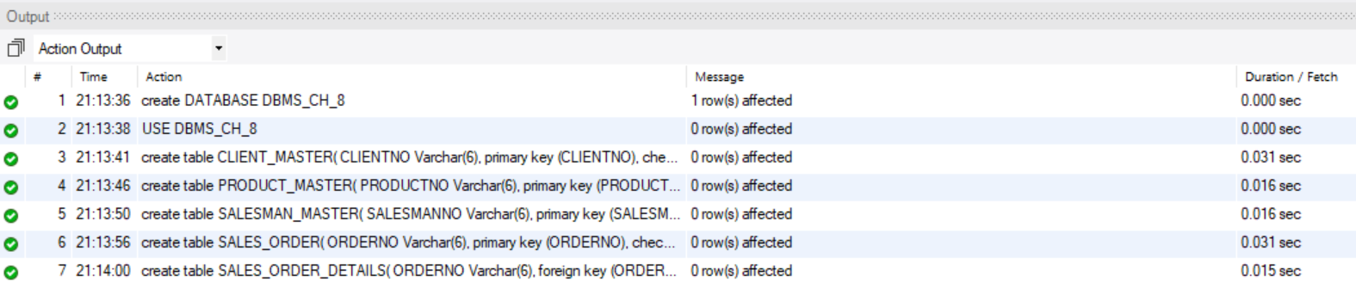

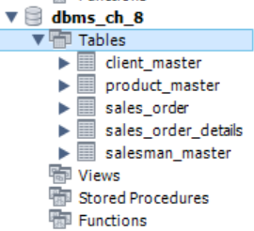

-- Create Database

create DATABASE DBMS_CH_8;

USE DBMS_CH_8;

-- Create Table CLIENT_MASTER 1 NO

create table CLIENT_MASTER(

CLIENTNO Varchar(6),

primary key (CLIENTNO),

check (CLIENTNO like 'C%'),

NAME Varchar(20) not null,

ADDRESS1 Varchar(30),

ADDRESS2 Varchar(30),

CITY Varchar(15),

PINCODE numeric(8),

STATE Varchar(15),

BALDUE Numeric(10,2)

);

-- Create Table PRODUCT_MASTER 1 no

create table PRODUCT_MASTER(

PRODUCTNO Varchar(6),

primary key (PRODUCTNO),

check (PRODUCTNO like 'P%'),

DESCRIPTION Varchar(15) not null,

PROFITPERCENT Numeric(4,2) not null,

UNITMEASURE Varchar(10) not null ,

QTYONHAND Numeric(8) not null,

REORDERLVL Numeric(8) not null,

SELLPRICE Numeric(8,2) not null,

check (SELLPRICE !=0),

COSTPRICE Numeric(8,2) not null,

check (COSTPRICE !=0)

);

-- Create Table SALESMAN_MASTER 1 no

create table SALESMAN_MASTER(

SALESMANNO Varchar(6),

primary key (SALESMANNO),

check (SALESMANNO like 'S%'),

SALESMANNAME Varchar(20) NOT NULL,

ADDRESS1 Varchar(30) not null,

ADDRESS2 Varchar(30),

CITY Varchar(20),

PINCODE Numeric(8),

STATE Varchar(20),

SALAMT Numeric(8,2) not null,

check (SALAMT !=0),

TGTTOGET Numeric(6,2) not null,

check (TGTTOGET !=0),

YTDSALES Numeric(6,2) not null,

REMARKS Varchar(60)

);

-- Create Table SALES_ORDER 1 no

create table SALES_ORDER(

ORDERNO Varchar(6),

primary key (ORDERNO),

check (ORDERNO like 'O%'),

CLIENTNO Varchar(6),

foreign key (CLIENTNO) references CLIENT_MASTER (CLIENTNO),

ORDERDATE date not null,

DELYADDR Varchar(25),

SALESMANNO Varchar(6),

foreign key (SALESMANNO) references SALESMAN_MASTER(SALESMANNO),

DELYTYPE Char(1) default 'F',

check(DELYTYPE in ('P','F')),

BILLYN Char(1),

DELYDATE date,

check (DELYDATE < ORDERDATE),

ORDERSTATUS Varchar(10),

check (ORDERSTATUS in ('In Process','Fulfilled','BackOrder','Cancelled'))

);

-- Create Table SALES_ORDER_DETAILS 1 no

create table SALES_ORDER_DETAILS(

ORDERNO Varchar(6),

foreign key (ORDERNO) references SALES_ORDER (ORDERNO),

PRODUCTNO Varchar(6),

foreign key (PRODUCTNO) references PRODUCT_MASTER(PRODUCTNO),

QTYORDERED Varchar(6),

QTYDISP Numeric(8),

PRODUCTRATE Numeric(10)

);

2.a) insert into CLIENT_MASTER select * from DBMS_CH_7.CLIENT_MASTER;



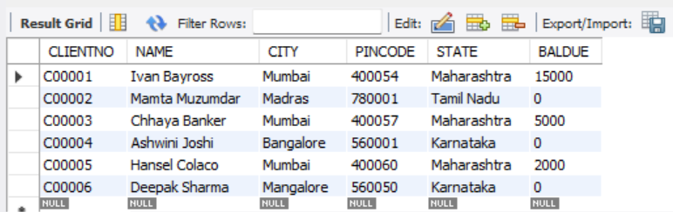

insert into PRODUCT_MASTER select * from DBMS_CH_7.PRODUCT_MASTER;



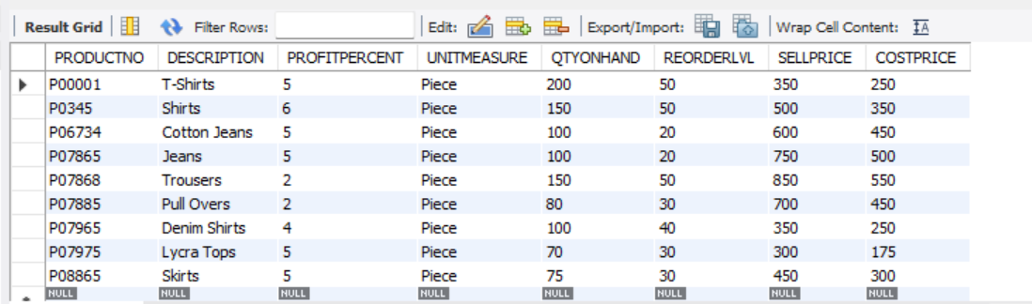

insert into SALESMAN_MASTER select * from DBMS_CH_7.SALESMAN_MASTER;





2.b)

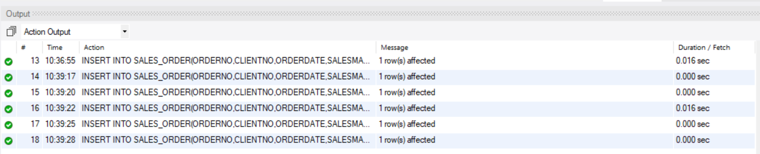

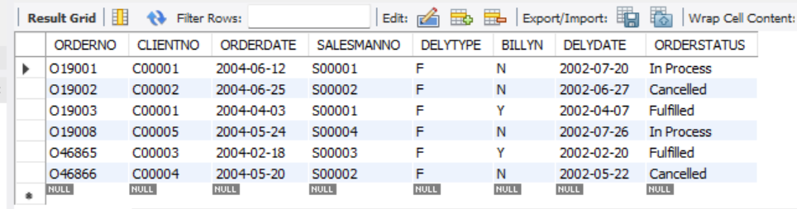

NICHERTA BAD DIBO

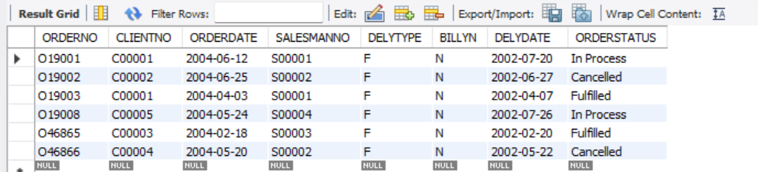

create table SALES_ORDER(

ORDERNO Varchar(6),

primary key (ORDERNO),

check (ORDERNO like 'O%'),

CLIENTNO Varchar(6),

foreign key (CLIENTNO) references CLIENT_MASTER (CLIENTNO),

ORDERDATE date not null,

SALESMANNO Varchar(6),

foreign key (SALESMANNO) references SALESMAN_MASTER(SALESMANNO),

DELYTYPE Char(1) default 'F',

check(DELYTYPE in ('P','F')),

BILLYN Char(1),

DELYDATE date,

check (DELYDATE < ORDERDATE),

ORDERSTATUS Varchar(10),

check (ORDERSTATUS in ('In Process','Fulfilled','BackOrder','Cancelled'))

);

INSERT INTO SALES_ORDER(ORDERNO,CLIENTNO,ORDERDATE,SALESMANNO,DELYTYPE,BILLYN,DELYDATE,ORDERSTATUS) VALUES('O19001','C00001',str_to_date('12-June-04','%d-%M-%y'),'S00001','F','N',str_to_date('20-July-02','%d-%M-%y'),'In Process');

INSERT INTO SALES_ORDER(ORDERNO,CLIENTNO,ORDERDATE,SALESMANNO,DELYTYPE,BILLYN,DELYDATE,ORDERSTATUS) VALUES('O19002','C00002',str_to_date('25-June-04','%d-%M-%y'),'S00002','F','N',str_to_date('27-June-02','%d-%M-%y'),'Cancelled');

INSERT INTO SALES_ORDER(ORDERNO,CLIENTNO,ORDERDATE,SALESMANNO,DELYTYPE,BILLYN,DELYDATE,ORDERSTATUS) VALUES('O46865','C00003',str_to_date('18-Feb-04','%d-%M-%y'),'S00003','F','N',str_to_date('20-Feb-02','%d-%M-%y'),'Fulfilled');

INSERT INTO SALES_ORDER(ORDERNO,CLIENTNO,ORDERDATE,SALESMANNO,DELYTYPE,BILLYN,DELYDATE,ORDERSTATUS) VALUES('O19003','C00001',str_to_date('03-Apr-04','%d-%M-%y'),'S00001','F','N',str_to_date('07-Apr-02','%d-%M-%y'),'Fulfilled');

INSERT INTO SALES_ORDER(ORDERNO,CLIENTNO,ORDERDATE,SALESMANNO,DELYTYPE,BILLYN,DELYDATE,ORDERSTATUS) VALUES('O46866','C00004',str_to_date('20-May-04','%d-%M-%y'),'S00002','F','N',str_to_date('22-May-02','%d-%M-%y'),'Cancelled');

INSERT INTO SALES_ORDER(ORDERNO,CLIENTNO,ORDERDATE,SALESMANNO,DELYTYPE,BILLYN,DELYDATE,ORDERSTATUS) VALUES('O19008','C00005',str_to_date('24-May-04','%d-%M-%y'),'S00004','F','N',str_to_date('26-July-02','%d-%M-%y'),'In Process');

2.c)

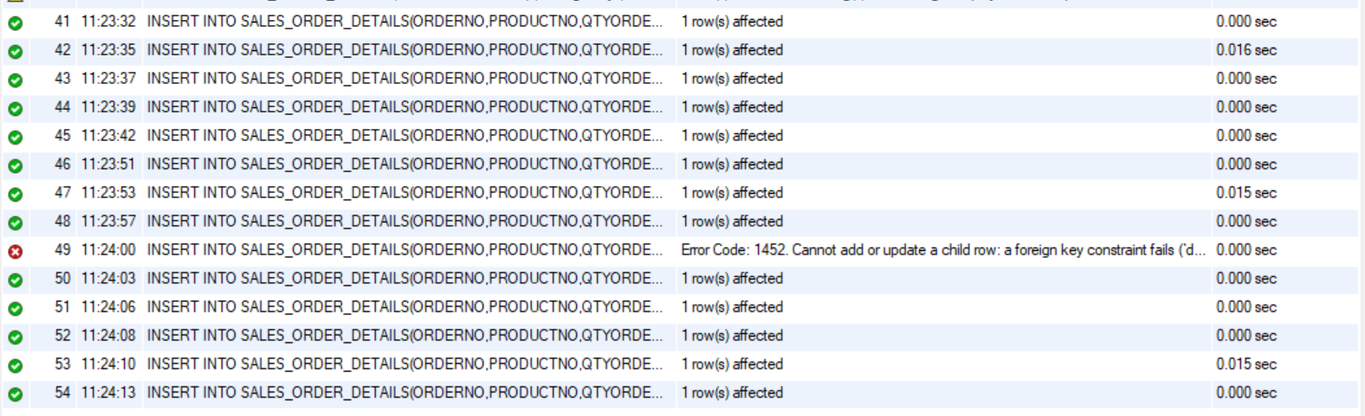

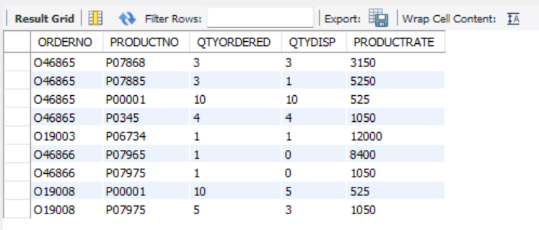

-- Create Table SALES_ORDER_DETAILS 1 no

create table SALES_ORDER_DETAILS(

ORDERNO Varchar(6),

foreign key (ORDERNO) references SALES_ORDER (ORDERNO),

PRODUCTNO Varchar(6),

foreign key (PRODUCTNO) references PRODUCT_MASTER(PRODUCTNO),

QTYORDERED Varchar(6),

QTYDISP integer(8),

PRODUCTRATE integer(10)

);

INSERT INTO SALES_ORDER_DETAILS(ORDERNO,PRODUCTNO,QTYORDERED ,QTYDISP,PRODUCTRATE) VALUES('O19001','P00001',4,4,525);

INSERT INTO SALES_ORDER_DETAILS(ORDERNO,PRODUCTNO,QTYORDERED ,QTYDISP,PRODUCTRATE) VALUES('O19001','P07965',2,1,8400);

INSERT INTO SALES_ORDER_DETAILS(ORDERNO,PRODUCTNO,QTYORDERED ,QTYDISP,PRODUCTRATE) VALUES('O19001','P07885',2,1,5250);

INSERT INTO SALES_ORDER_DETAILS(ORDERNO,PRODUCTNO,QTYORDERED ,QTYDISP,PRODUCTRATE) VALUES('O19002','P00001',10,0,525);

INSERT INTO SALES_ORDER_DETAILS(ORDERNO,PRODUCTNO,QTYORDERED ,QTYDISP,PRODUCTRATE) VALUES('O46865','P07868',3,3,3150);

INSERT INTO SALES_ORDER_DETAILS(ORDERNO,PRODUCTNO,QTYORDERED ,QTYDISP,PRODUCTRATE) VALUES('O46865','P07885',3,1,5250);

INSERT INTO SALES_ORDER_DETAILS(ORDERNO,PRODUCTNO,QTYORDERED ,QTYDISP,PRODUCTRATE) VALUES('O46865','P00001',10,10,525);

INSERT INTO SALES_ORDER_DETAILS(ORDERNO,PRODUCTNO,QTYORDERED ,QTYDISP,PRODUCTRATE) VALUES('O46865','P0345',4,4,1050);

INSERT INTO SALES_ORDER_DETAILS(ORDERNO,PRODUCTNO,QTYORDERED ,QTYDISP,PRODUCTRATE) VALUES('O19003','P03453',2,2,1050);

INSERT INTO SALES_ORDER_DETAILS(ORDERNO,PRODUCTNO,QTYORDERED ,QTYDISP,PRODUCTRATE) VALUES('O19003','P06734',1,1,12000);

INSERT INTO SALES_ORDER_DETAILS(ORDERNO,PRODUCTNO,QTYORDERED ,QTYDISP,PRODUCTRATE) VALUES('O46866','P07965',1,0,8400);

INSERT INTO SALES_ORDER_DETAILS(ORDERNO,PRODUCTNO,QTYORDERED ,QTYDISP,PRODUCTRATE) VALUES('O46866','P07975',1,0,1050);

INSERT INTO SALES_ORDER_DETAILS(ORDERNO,PRODUCTNO,QTYORDERED ,QTYDISP,PRODUCTRATE) VALUES('O19008','P00001',10,5,525);

INSERT INTO SALES_ORDER_DETAILS(ORDERNO,PRODUCTNO,QTYORDERED ,QTYDISP,PRODUCTRATE) VALUES('O19008','P07975',5,3,1050);

Chapter-9

1.a) select name from client_master where name like '_a%';

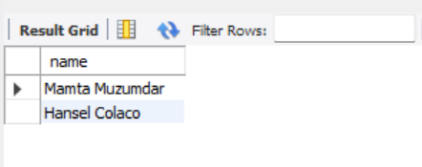

1.b) select * from client_master where city like 'M%';

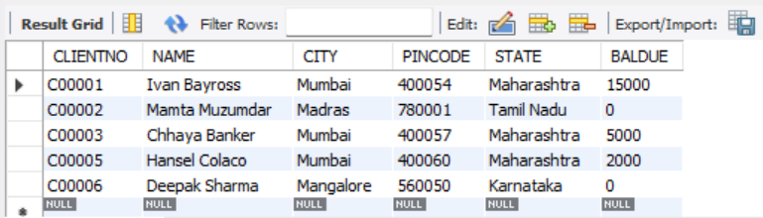

1.c) select * from client_master where city='Bangalore' or city='Mangalore';

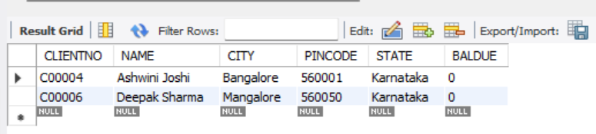

1.d) select * from client_master where baldue>10000;

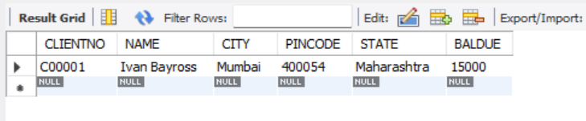

1.e) select * from sales_order where ORDERDATE like '_____06___';

Or

select * from sales_order where monthname(orderdate)='June';

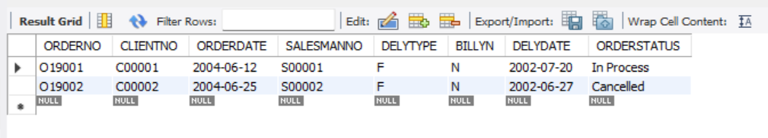

1.f) select * from sales_order where clientno in ('C00001','C00002');

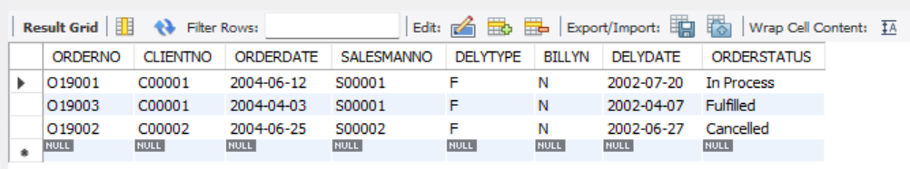

1.g) select * from product_master where sellprice>500 and SELLPRICE<=750;

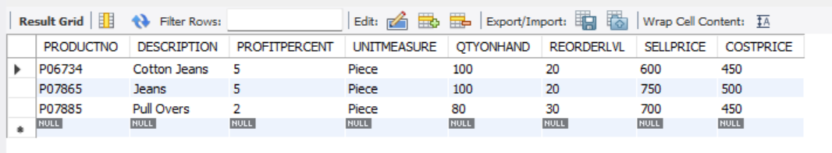

1.h) select productno,description,sellprice,sellprice*15 new_sellprice from product_master where sellprice>500;

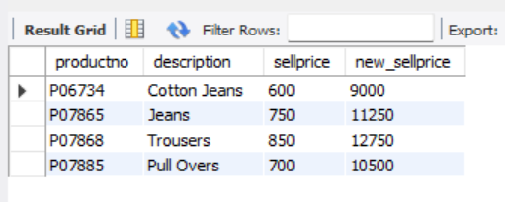

1.i) select name,city,state from client_master where state not in ('Maharashtra');

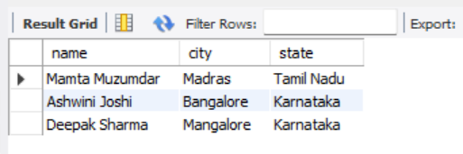

1.j) select count(orderno) as number_of_orders from sales_order;

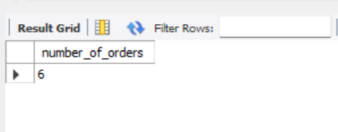

1.k) select avg(sellprice) from product_master;

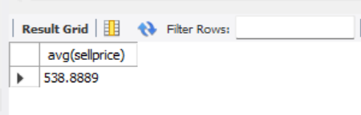

1.l) select max(sellprice),min(sellprice) from product_master;

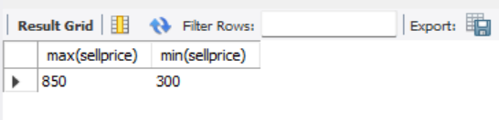

1.m) select count(productno) from product_master where SELLPRICE>=500;

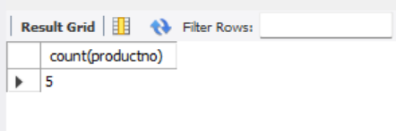

1.n) select * from product_master where qtyonhand<reorderlvl;

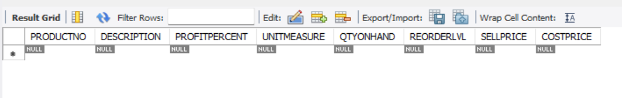

2.a)

Chapter-10

1.a) select description,count(qtyordered) from product_master,sales_order_details where sales_order_details.PRODUCTNO=product_master.productno group by description;

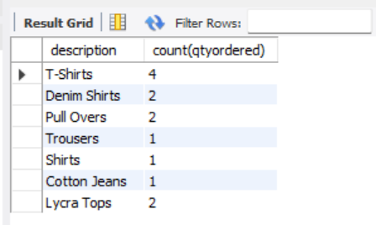

Ashraf:

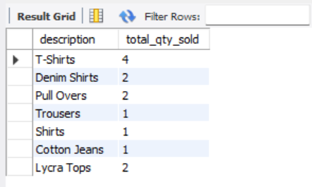

select description,count(qtyordered) as total_qty_sold from sales_order_details as sod ,product_master as pm where sod.productno=pm.productno group by description;

1.b) Ashraf:

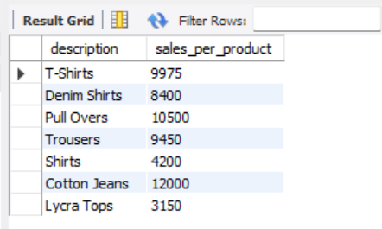

select description , sum(sod.qtydisp*sod.productrate) as sales_per_product from sales_order_details as sod ,product_master as pm where sod.productno=pm.productno group by sod.productno, pm.description;

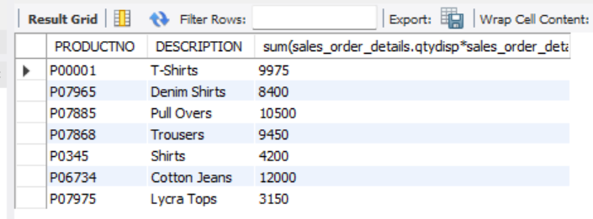

select sales_order_details.PRODUCTNO,product_master.DESCRIPTION,sum(sales_order_details.qtydisp*sales_order_details.productrate) from sales_order_details,product_master where sales_order_details.PRODUCTNO=product_master.productno group by sales_order_details.productno, product_master.description;

1.c) ashraf

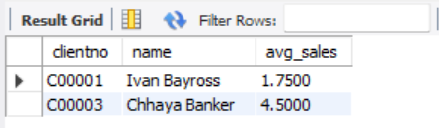

select cm.clientno,cm.name,avg(sod.qtydisp) as avg_sales from sales_order_details as sod , sales_order as so , client_master where client_master.clientno=sales_order.clientno and sales_order.orderno =sales_order_details.orderno group by cm.clientno,name having max(sod.qtyordered*sod.productrate)>15000;

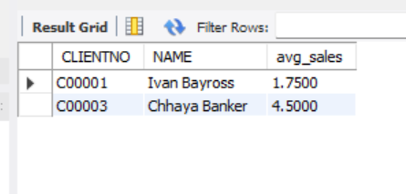

select client_master.CLIENTNO,client_master.NAME,avg(sales_order_details.qtydisp) as avg_sales from sales_order_details, sales_order, client_master where client_master.clientno=sales_order.clientno and sales_order.orderno = sales_order_details.orderno

group by client_master.clientno,name having max(sales_order_details.qtyordered*sales_order_details.productrate)>15000;

sales order table ta



1.d)

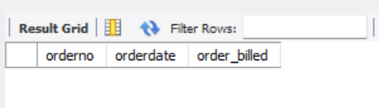

select so.orderno,so.orderdate,sum(sod.qtyordered*sod.productrate) as order_billed from sales_order as so ,sales_order_details as sod where sod.orderno = so.orderno and so.billyn='Y'

and MONTHNAME(orderdate) = 'June' group by so.orderno;

2.a) ashraf

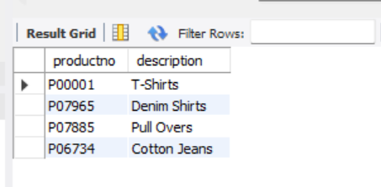

select sod.productno,pm.description from product_master as pm join sales_order_details as sod on pm.productno = sod.productno join sales_order as so on so.orderno=sod.orderno join client_master as cm on

cm.clientno = so.clientno and cm.name='Ivan Bayross';

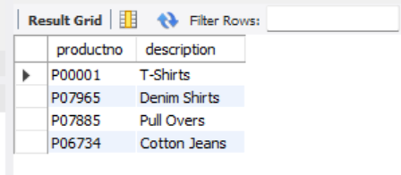

select sales_order_details.productno,product_master.description from product_master join sales_order_details on product_master .productno = sales_order_details.productno join sales_order on sales_order.orderno=sales_order_details.orderno join client_master on

client_master.clientno = sales_order.clientno and client_master.name='Ivan Bayross';

2.b) ashraf

select sod.productno,pm.description,sum(sod.qtyordered) as total_qty from product_master as pm join sales_order_details as sod on pm.productno=sod.productno join sales_order as so on so.orderno = sod.orderno

where MONTHNAME(so.delydate)= MONTHNAME(CURDATE()) group by sod.productno,pm.description;

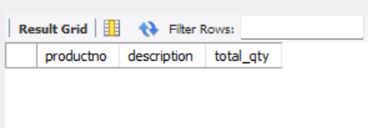

2.d) ashraf

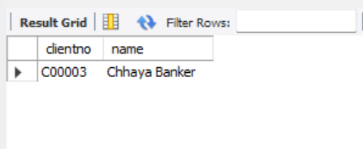

select distinct so.clientno,cm.name from product_master as pm join sales_order_details as sod on pm.productno=sod.productno join sales_order as so on so.orderno = sod.orderno join

client_master as cm on cm.clientno = so.clientno where pm.description="Trousers";

2.e) ashraf

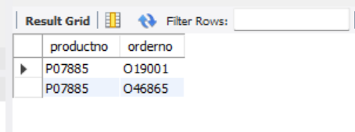

select sod.productno,sod.orderno from product_master as pm join sales_order_details as sod on pm.productno=sod.productno join sales_order as so on so.orderno = sod.orderno

where sod.qtyordered<5 and pm.description="Pull Overs";

2.f) ashraf

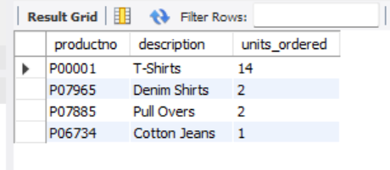

select sod.productno,pm.description,sum(sod.qtyordered) as units_ordered from product_master as pm join sales_order_details as sod on pm.productno=sod.productno join sales_order as so on so.orderno = sod.orderno

join client_master as cm on cm.clientno = so.clientno where (cm.name="Ivan Bayross" or cm.name="Mamta Muzumdar") group by sod.productno , pm.description;

2.g) ashraf

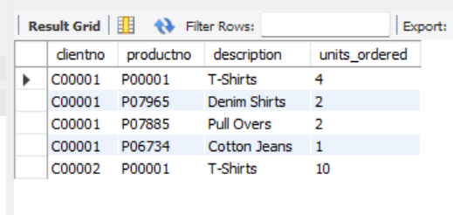

select so.clientno,sod.productno,pm.description,sum(sod.qtyordered) as units_ordered from product_master as pm join sales_order_details as sod on pm.productno=sod.productno join sales_order as so on so.orderno = sod.orderno

join client_master as cm on cm.clientno = so.clientno group by so.clientno,sod.productno , pm.description having so.clientno='C00001' or so.clientno='C00002';

select productno,description from product_master where productno Not In(select productno from sales_order_details);

2.c)ashraf

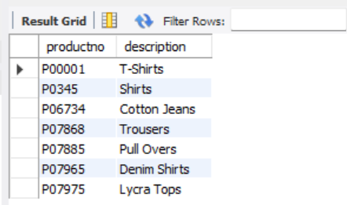

select distinct pm.productno,pm.description from sales_order_details as sod join product_master as pm on pm.productno=sod.productno;

3.a) ashraf

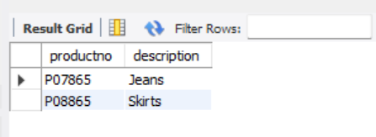

select productno,description from product_master where productno Not In(select productno from sales_order_details);

3.b) ashraf

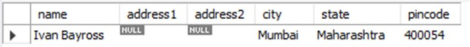

select name,address1,address2,city,state,pincode from client_master where client_no In(select client_no from sales_order where order_no='O19001');

3.c)

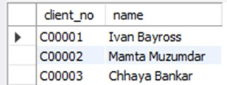

select client_no,name from client_master where client_no In(select client_no from sales_order where DATE_FORMAT(order_date ,'%M-%y')<'May-02');

3.d)

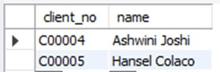

select client_no,name from client_master where client_no In(select client_no from sales_order where order_no In(select order_no from sales_order_details where product_no

 In(select product_no from product_master where description ='Lycra Tops')));

3.e)

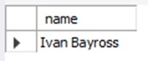

 select name from client_master where client_no In(select client_no from sales_order where order_no In(select order_no from sales_order_details where (qty_ordered*product_rate)>=10000));

Chapter-11